Antisystemic Effects of Antimining Andean Peasant Struggles
Abstract
The metabolic structural processes of the capitalist world-economy have produced historical antisystemic resistances with world-scale effects over capital's extended reproduction. The history of the Andean indigenous and cholo peasantry struggles against colonial and imperialist mining constituted a new political identity in absolute contradiction with the dispossession and destruction of land and water as vital values for their social reproduction. While theory has been developed about the antisystemic effects of social movements created by the systemic processes of the world-economy, theorizing on their causal mechanisms is a work in progress, permeable to be developed broadly within a Marxist critique of imperialism political economy. In this article, a causal mechanisms hypothesis is built to explain the world-scale effects of antimining struggles over the finance capital reproduction circuit of mining imperialists bourgeoisies in competition under the gradual breakout conditions of shared imperialism in Los Andes from three case studies: i) the cholo-peasantry antimining struggles in Cajamarca (Peru) during the 2004 and 2011-2012 against the Newmont Gold Mining Corporation headed in the U.S., ii) the indigenous-peasantry mining struggles in Apurímac (Peru) during 2015 and 2019 against the MMG of China Minmetals Corporation (CMC), and iii) the indigenous-cholo peasantry antimining struggles in Cotopaxi (Ecuador) during 2023-2024 against the Atico Mining Corporation headed in Canada. The theory-building case studies conducted have been nurtured by fieldwork, archive research, and protest event data analysis to evidence the consistency of the hypothesis stated on the antisystemic effects of antimining struggles.
Keywords: Peru; Ecuador; China; United States of America; Canada; Antimining struggles; Antisystemic; Capital reproduction; Mining; Imperialism
Resumen
Los procesos metabólicos de reproducción de la economía-mundo capitalista han producido históricamente resistencias antisistémicas con efectos a escala mundial sobre la reproducción extendida del capital. Las luchas del campesinado cholo-indígena contra la minería colonial e imperialista en Los Andes forman un sujeto político en absoluta contradicción con el despojo y la destrucción de la tierra y el agua como valores vitales para su reproducción social. Si bien se ha desarrollado teoría sobre los efectos antisistémicos de los movimientos sociales creados con los procesos sistémicos de la economía-mundo, la teorización sobre los mecanismos causales que pueden explicar dichos efectos, es una labor en curso permeable a ser desarrollada a la luz de una crítica marxista a la economía política del imperialismo. En este artículo, construyo una hipótesis de mecanismos causales para explicar los efectos antisistémicos de las luchas antimineras sobre la reproducción del capital financiero circulado en la industria minera por burguesías imperialistas en competencia bajo condiciones de ruptura progresiva del imperialismo compartido en Los Andes, a partir de tres estudios de caso: i) las luchas antimineras del campesinado cholo en Cajamarca (Perú) durante los años 2004 y 2011-2012 contra la Newmont Gold Mining Corporation asentada en EE.UU., ii) las luchas del campesinado indígena en Apurímac (Perú) durante 2015 y 2019 contra la MMG de la China Minmetals Corporation (CMC), y iii) las luchas antimineras campesinas cholo-indígenas en Cotopaxi (Ecuador) durante 2023-2024 contra la canadiense Atico Mining Corporation. Los estudios de caso realizados para la construcción de teoría se han nutrido de trabajos de campo, revisión de archivos, así como del análisis de catálogos de eventos de protesta para evidenciar la consistencia de la hipótesis construída sobre los efectos antisistémicos de las luchas antimineras.
Palabras clave: Perú; Ecuador; China; Estados Unidos; Canadá; luchas anti-mineras; anti-sistémico; reproducción de capital; minería; imperialismo

Introduction
The antisystemic effects of the antimining movement in Los Andes express the advanced development of class struggle with the identity formation of historical challengers in absolute contradiction to the reproduction of the imperialists bourgeoisies finance capital through the mining circuit of accumulation. Mining in Los Andes is at the center of the foundational processes of the modern world-system and in the metabolic processes of reproduction of finance capital in the current world-economy. The development of the processes of production and circulation of colonial and imperialist mining, and gold mining in particular, have structured the social formation and historical resistance of the indigenous-cholo peasantry, against militarism, dispossession and expansive destruction of the vital values for their social reproduction: water and land.
This is evidenced by the genocide of the “indigenous” peoples of Abya Yala, the exploitation of the survivors in colonial mining, as well as the massacres of their proletarianized children and grandchildren indigenous-cholo peasants by the imperialist implantation of U.S. monopolist capitalists trusts’ finance capital inter-“nationalized” on mining enclaves in Los Andes. Militarism as a policy of expansion of the imperialists bourgeoisies to control or guarantee the functioning of the mining circuit for the reproduction of their finance capital, is a persistent feature of the coloniality of the current mining problem. As well as a nodal point of his antiimperialist solution in Los Andes. In the origine of the formation of the modern world-system that began in the sixteenth century and in the world-economy of imperialism development during the late nineteenth and early twentieth century, the massacres and exploitation of the indigenous-cholo proletarianized peasantry in the mines of Los Andes operated as a constant under colonial mining and imperialist mining.
Colonial mining in Los Andes was the foundational method of the expanded original accumulation of the sixteenth century (Cueva [1977]1999:63–78; Marx [1886]1976:874-875,915) corresponding to the material expansion of the European oligarchic banking bourgeoisies (Arrighi 1994) that emerged from the concentration of merchant capital in the Middle East during the thirteenth century (Abu-Lughod 1991), shaping the modern world-system. Imperialist mining is a vital process of production and hoarding for the extended reproduction of finance capitals with differentiated trajectories of centralization and concentration (Bukharin [1929]1966) guaranteeing their inter-“nationalization” through militarism (Luxemburg [1913]2015).
In their effort to conceptualize the antisystemic effects of the movements produced by the systemic structural processes of the world-economy, Arrighi, Hopkins, and Wallerstein (1989:90) treated the antisystemic effects as caused by the centralization of capital as a world-scale tendency highly developed under the world-economy of imperialism, and highlighted the divergence of the potentially challenging [new] social sites of the antisystemic movements. However, the causal mechanisms that connect the constitution of antisystemic identities in absolute antagonism with the metabolic need for expansive reproduction of contending finance capitals with differentiated trajectories of centralization and concentration have not yet been evidenced.
As the events presented, the emergence of new challengers with not only abstract but absolute antagonistic identities appears as reminders of the development of the history of class struggle. We build a hypothesis of causal mechanisms to answer the question: How do the anti-mining struggles produce anti-systemic effects on the capital reproduction of imperialist bourgeoisies? We argue that the antisystemic effects of historical challengers formed by the expansive structural processes vital for the reproduction of competing finance capitals under conditions of shared imperialism in Los Andes, are real in their consequences.
Antimining struggles have world-scale effects over the decreasing of the rate of profit of the top-layer of the imperialists bourgeoisies, the inter-“national” bank state capitalists trusts by: the obstruction of the circulation time in the transformation of surplus value into profit, as well as disrupting the advanced capital organic composition of the imperialist bourgeoisies investing in the mining reproduction circuit of accumulation, over the state capitalist’s trusts gold-money-capital hoarding and trade. The effects of antimining struggles on the metabolic mechanisms of capital reproduction are antisystemic, also because its absolute antagonist contestation exacerbates the imperialistic competence for material expansion facing a forthcoming re-partition imperialists wars.
We state the following hypothesis: the Indigenous-cholo historical antisystemic resistances formed with, and in antagonism to, the systemic structural processes vital for extended capital reproduction are real by its effects (Merton 1948). The antimining struggles have antisystemic effects by decreasing the rate of profit of top-layer-class of the world-economy of imperialism expected to revenue through the circuit of mining accumulation, by effectively blocking its capital circulation with obstructive performances of struggle. In that manner, delaying its circulation time and disrupting the expected organic composition of finance capital advanced in the production of surplus-value, shaped as a mass of mining-commodity-capital, and its posterior metamorphosis into total super-profit.
Indigenous-cholo antimining struggles, indeed, triggers gold hoarding by imperialists bank state trusts, because gold-holdings are money-capital and commodity-capital at the same time. But in contrast with monetized-capital in form of paper-money -pure currency-, gold-money-capital hold its surplus-value form of commodity-capital. And in that manner, its transformation in profit can be delayed when the rate of profit decreases. As we will explain here onward, because of the delay in the circulation of the finance capital of the international bank capitalists state trusts, the antisystemic obstruction of antimining struggles trigger the raising of the constant capital magnitude of its organic capital composition, amplifying its decreasing effect in the rate of profit, and consequently a reduced amount of surplus-value is transformed into total profit. Indeed, disrupting the production of surplus value and the rate of profit expected by the imperialists bourgeoisies in ongoing militarist competition for the expansion of their mining accumulation circuits by means of imperialist wars or imperialists interventions oriented to establish its relations of production on the “national-economies” in which the mining precious “raw” materials are situated as in Los Andes or Palestine.

Antisystemic resistance of historical challengers: the antimining movement of the indigenous-cholo Andean peasantry
The formation of the class structure of the modern world-system is founded on the racialized international division of labor produced by colonization as a policy of expansion of merchant capital. Around ten million “indigenous" survived the genocide planned in Los Andes of an estimated total of sixty five million exterminated over the continental “America", being sublimated as inferior beings and reduced to mere labor force by the colonization method of primitive accumulation (Marx [1886]1976:873– 875, 914; Mariátegui, January 16, 1929:78; Quijano and Wallerstein 1992; Quijano [1999], 2007, 169-170; Mignolo 2011, 183–84).
The world no longer fit into the consciousness of the survivors. But in their collective consciousness a myth survived. Or a myth makes sense in our consciousness, it is the myth of the new indigenous, of the Inkarri (the Inka return), of the Yawar-Inti (Sun of Blood) and the resurgence of the “indigenous" world by a revolutionary vendetta. In opposition to Arboleda's (2020) interpretation of the formation of indigenous “identity politics", I argue that the revolutionary subjectivity that conjures up indigenous socialism is a historical formation in movement, a block of living historical text clashing, developing the peasantry as an antagonist class in formal subsumption since the sixteenth century.
For both Arboleda (2020) and Bolívar Echevarría, the indigenous peoples could not understand the antagonism between them and the Spaniards. Their cosmology, they believe, did not allow the indigenous to realize that they were being killed by an external collective antagonistic to their lives or “collective self”. If someone follows that argument, by implication this indigenous “self-defeating cultural essentialisms” would only change with the later appropriation of Hegelian logic as the basement for the reproduction of the sublimating rationality of “European mentality". By implication, it is since the encounter of the “indigenous” peoples with this “European mentality” that their descendants are able to interpret “the cultural other in terms of radical otherness, as an absolute negation of its own identity”. In short, it must be understood that Bolívar Echevarría should have ideologically omitted the work of the Peruvian anthropologist Luis E. Valcárcel, so as not to force an approximation to the work of José Carlos Mariátegui, who found an indigenous revolutionary subject already in motion when they were going to work on its politicization at the beginning of the twentieth century. Fortunately, the work of Alberto Flores Galindo ([1985]2010) did justice to this problem by tracing the myth of the Inkarri in indigenous and popular struggles emblematic of the history of Peru.
As the first worker-intellectuals became the prophets of this myth, indigenous socialism was forged in the early twentieth century as the convergence of the “cholo group" with the indigenous peasantry in historical resistance. The work of socialist politicization undertaken by Mariátegui, Mayer and Valcárcel (among others) in the organization of the bases of socialism in Peru and in the creation of indigenous socialism, they found already in motion the myth of indigenous resurgence. In which framework of interpretation, the revolution is carried out as vendetta for the new indigenous, their remnants, their sons and grandsons. The socialist revolution as a movement and horizon was already operating in Los Andes, when El Amauta José Carlos Mariátegui and the cholo group which he constituted with other intellectual workers of the proletariat in formation, began their work of politicization.
Mariátegui wrote in the prologue to Valcárcel's Tempest in Los Andes (1927): “I remember the unexpected and impressive type of agitator I found four years ago in the indigenous from Puno, Ezequiel Urviola. This meeting was the greatest surprise that Peru had in store for me on my return from Europe. Urviola represented the first spark of a fire that was to come. He was the revolutionary indigenous, the socialist indigenous. Tuberculous, hunchbacked, he succumbed after two years of tireless work. Today it does not matter that Urviola does not exist. It is enough that he existed. As Valcárcel says, today the mountains are pregnant with spartacus" (Mariátegui in the prologue to Valcárcel 1927:11).
The history of the class struggle in Los Andes definitely precedes socialism, but most important, the indigenous-cholo peasantry learned to instrumentalize it. Thus, by the first quarter of the twenty-first century, the indigenous-cholo peasantry has not only effectively instrumentalized socialism (and Marxism) but also environmentalism (Mejía 2021; 2024), fixing its discursive articulation on the recognition of sensitive entities such as mountains, rivers, and lagoons (de la Cadena 2010). As De la Cadena emphasized about the visionary work of José María Arguedas: “[t]he totality, Todas las Sangres proposed an alternative indigenous social movement, a critical ally of the modern left, but with its own a-modern hybrid logic. Literacy and modern politics were important, but they had to be used and translated selectively, rather than eradicating indigenous customs" (2005:18).
Hybridity in this sense is performative and not a reproduction of Western modernization as acculturation, but rather the cholos as indigenous descendants have been building their own cultural logic that recognizes their origins, while appropriating Western-modern cultural objects, as we do with the socialist and ecological frames of interpretation in the antimining and mining struggles of the twenty- first century. As evidence the three case studies: i) the cholo-peasantry antimining struggles in Cajamarca (Peru) during the 2004 and 2011-2012 against the Newmont Gold Mining Corporation headed in the U.S., ii) the indigenous-peasantry mining struggles in Apurímac (Peru) during 2015 and 2019 against the MMG of China Minmetals Corporation (CMC), and iii) the indigenous-cholo peasantry antimining struggles in Cotopaxi (Ecuador) during 2023-2024 against the Atico Mining Corporation headed in Canada. The cholo-indigenous peasantry updated their interpretation of mining from a class perspective, nurtured by ecological discourses and indigenous cosmopolitics (de la Cadena 2020) in the defense of water, land, life and biodiversity.

The Historical Resistance of the Cholo-Indigenous Peasant Struggles Against Imperialist Mining in Los Andes
Imperialist mining is a central productive and hoarding process for the extended capital reproduction of the most advanced economic formations of the imperialism world-economy in competition for their inter-“nationalization". Although the institutional and military foundations of imperialist domination in Los Andes were settled with the implantation of the monopolistic finance capital of the most centralized bank capitalists state trusts of the U.S., through extractive enclaves on the most profitable industries in semi-feudal and semi-colonial “national-economies” during the period 1895 to 1930. From the beginning of the twentieth century, the mining industry in Los Andes was under the almost exclusive control of the U.S. imperialist bourgeoisie. Mining was one of the industries where capitalism developed most rapidly, especially in Los Andes, where from 1895 monopoly capital was directed toward large-scale mining, oil production, and agriculture (Mariátegui [1928]2011:245-249; Cueva [1977]1999:63-64; Quijano [1977]1988:114-121).
In fact, the struggles of the central Peruvian highlands mining workers unions were executing active antisystemic resistance since their genesis with the first miners strike against the Cerro de Pasco Corporation (CPC) of January 7, 1919 -inspired in the advancements of the proletariat in Europe and the Soviet Revolution of October 1917 (Melgar Bao 2020:132)- until the end of the 1980s. The processes of union formation and politicization of the mining proletariat of the central highlands of Peru went through a trajectory of radicalization during most of the twentieth century. This trajectory of radicalization diffused to the medium and small mines at the national level, as well as to the mines of the southern highlands –as was evidenced by the massacres of 1957 and 1966 in the mines of Toquepala (Moquegua), exploited by the Southern Peru Copper Corporation (SPC)–. Mines opened for the “nationalization" of the finance capital of the U.S. imperialist bourgeoisie through the Cuajone contract, secretly signed by the “nationalist" military government of Velasco Alvarado.
While during the 1980s, the co-optation of the mining workers unions of the Southern Peru Copper Corporation (SPC) was consolidated as a result of the enforcement of its institutionalization trajectory. Meanwhile, the intensity and harshness of the militarism executed against the protests of the mining workers in the central Peruvian highlands exploited by the Cerro de Pasco Copper Corporation (CPC), evidenced the disruptiveness of the transgression carried out by the mining workers struggles as a direct challenge to the main reproduction circuit of capital accumulation. The systematic application of militarism is the sole guarantee to hold its imperialist policy over the mines of the central highlands of Peru was evidenced in the massacres of Malpaso (1930), Cobriza (1971), as well as the militarized repression of the miners' strike campaign of the mid-80s repressed with the imprisonment of hundreds of unionized miners, and the assassination of Saúl Cantoral in 1988 by the “Commando Rodrigo Franco" task force (a paramilitary criminal organization for annihilation that operated under the first government of Alan García).
However, the radicalization of the miners' strikes developed facing militarized repression and military regimes. The formation of a vanguard of the Peruvian proletariat in open confrontation with the U.S. imperialist mining bourgeoisie, developed until the 1980s, when the Communist Party of Peru-Sendero Luminoso (PCP-SL) and the Tupac Amaru Revolutionary Movement (MRTA) began armed struggles. The trajectory of radicalization of the struggles of the miners became an anti-imperialist challenge, operated in a context characterized by the escalation of the armed struggle in Latin America, by the consequences of the Sino-Soviet secession, and the resolution of the imperialists wars between the U.S.S.R. and the U.S.. The formation of the basis for the horizontal centralization of Sino-American finance capital developed, gradually after the shared imperialist resolution of the Vietnam War, and the subsequent implementation of market reforms in China by Deng XiaoPing in 1978, until the early years of the 21st century, marked by the September 11 of 2001 attacks on Wall Street, the Pentagon and the White House. When, under conditions of shared imperialism, these financial capitals begin a process of separation and rupture, gradually reducing their horizontal centralization. Thus, constraining the inter-“nationalization" of U.S. bank capitals as finance capital circulating through the economic formations of China's industrial production
Indeed, U.S. and China imperialists bourgeoisies share the conditions of accumulation for their mutually consented capital concentration and inter-“nationalization" in the period between the 70s and the first decade of the 2000s, with a breaking point in the years 2013-2015, denoting a initial disentangle of their rates of profit, that could be extended mildly until 2019, with a recent affirmation between 2021 and 2023, which supposed to be reinforced with the updated data which considers the 2024 interstate contention. Considering its estimation as a proxy to the monetized-capital amount accountable for the exchange of gold-money-capital reserves as a reserve fund of surplus-value congealed under the shape of gold-commodity-capital and gold-money¬capital at the same time (Figure 4).
The finance capital advanced inter-“nationalization” of a highly centralized China state capitalists trust during the 2000s,, gradually took advantage of the institutional and military conditions established by the U.S. imperialists bourgeoisies to operate in Peru. In twenty years, China's state capitalists trust finance capital built a considerable expansion of its participation in Peruvian copper mining, although still incipient in gold mining, through the China Minmetals Corporation (CMC). The differentiated imperialists mining bourgeoisies are in the core of the inter-“nationalized” organization of finance capital, subjugating the industrial mining production of the semi-colonial “national-economies" in Los Andes, to the whole circuit of reproduction of the highest economic formations resultant from differentiated trajectories of centralization at a “national-economy" scale. Correspondent to the higher levels of capital concentration of the world-economy of imperialism, since the transition from Great Britain to the U.S. modern world-system hegemony, around the first years of the “long twentieth century" (Arrighi 1994).
Under this situation of breaking shared imperialism in Los Andes, a political regime of militarism and terrorist state violence is indiscreetly instrumentalized to guarantee the maximums rate of surplus-value and rate of profit for the top-layer economic formations at a world-scale. Nevertheless, the horizontal decentralization of Sino- American financial capital have differentiated effects for the accumulation circuit of each imperialist bourgeoisie, according to its own levels of concentration and centralization. In addition, the effects on a world-scale of the advanced horizontal decentralization of Sino-American finance capitals, exhibit differentiated consequences on the systemic structural processes of production and circulation, shaping the next transitory formation that necessarily will imply a new international division of labor.

The antisystemic effects hypothesis for antimining struggles
The advancement of money-capital by bank capitalists through the circuit of mining reproduction in Los Andes produces surplus-value shaped and weighted as commodity-capital ready for being converted in the total profit form of surplus-value by its market sale, in which case its surplus-value form is gone. But, in the case of gold, at the same time can be accounted as money-capital able for being transformed into profit by its exchange for pure currency money-capital, or can either still being gold hoarded under its commodity-capital shape (see Figure 2 and Figure 3). In that manner, gold retains its surplus-value form embodied in the volume of gold commodity-capital produced by a determined organic composition of finance capital advanced for mining under concrete natural, cultural, and historical conditions.
The natural and cultural conditions are determinants for the reproduction of the finance capital invested in mining production and commercialization by bank state capitalists trusts. When the economic formations developed with the concentration and centralization processes saturated its “national-economy" scale, the fierce competition for a highly advanced inter-“nationalization" development operate by the pure militarism of imperialists wars in Ukraine, Palestine, and probably soon in Taiwan. And by mean of imperialists securitization interventions on semi-colonial “national-economies", as the militarized repression over the massive uprisings of Ecuador (2019) (Iza, Tapia and Madrid 2020), Chile (2019), Colombia (2020-2022), Peru (2022-2023) (Montoya and Quiroz 2023), and most recently Venezuela (2024).
By inter-“nationalization" we mean the process in which bank capitalists trusts organizes the allocation of their money-capital threw as “foreign direct investment" to the most profitable and strategic industries, becoming finance capital situated in the territory of a semi-colonial state for the aims of its reproduction. Taking advantage of the wages differences correspondent to the world division of labor hidden under the less mysterious and elder phenomenon of “globalization", “transnationalization", or much honest “inter-nationalization" of production in the world-economy of imperialism (Marx [1864-1865]2017:47-54; Bukharin [1915]1966:17-18, 53, 60-62; Lenin [1917]1964:260, 265-266, 278-279).
The bank capitalists state trusts investments are backed up in gold-world-money-capital proportional to an expected potential amount of money-capital which are able to realize by the circulation process in the transformation of surplus-value into profit (Marx, [30 April 1868]1988:21-24). Guaranteeing onward its differentiated reproduction scales for a further stage of capitalism development, at a historical time in which the irresolute tendency of its contradictions are expressed in the ecological, productive and shared imperialism crisis.
The antimining struggles have antisystemic effects obstructing the circuit of mining reproduction of certain finance capitals. More specifically, the successful contentious campaigns of mining protests and antimining struggles in Los Andes involved the sustained execution of obstructive performances of struggle, such as the blockade of roads or the protective occupation of mountains and lagoons, as have been done in Cajamarca and Apurímac in Peru, and Cotopaxi in Ecuador, as in other territories in Colombia, Chile and most recently Argentina, to stop imperialists mining projects (Mejía 2021:97-99).
Indeed, the indigenous-cholo peasantry blockade the production and transportation of a compromised volume of mining commodity-capital, during an expected circulation time, and with a predetermined organic composition. The increment of the time of circulation in the transformation of surplus-value into profit, delays the consumption of the finance capital invested in constant capital, increasing the difference between the rate of surplus-value and the rate of profit, an indeed transforming a reduced magnitude of surplus-value into total profit.
When the surplus value is transformed into total profit during an expected circulation time, i.e. a year, the following dynamics describe this process of metamorphosis, s’—meta—> p’ (Marx [1864-1865]2017:49-55):
- The total capital advanced (C) to any circuit of reproduction have two components: constant capital (c), and variable capital (v). As v is always necessarily greater than cero, if c is greater than cero, then C is greater than v
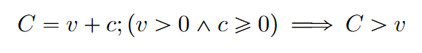
- The rate of surplus-value (s’) is equal to the ratio of the surplus-value (s) and the variable capital (v); and the rate of profit (p’) is equal to the ratio of the surplus-value (s’) to the total capital (k)
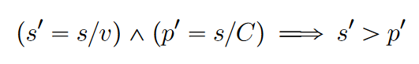
- The difference between the rate of surplus-value (s’) and the rate of profit (p’) is
related to the rate of profit (p’) as the constant capital (c) is related to the variable capital (v). And, the rate of profit (p’) is related to the rate of surplus-value (s’) as the variable capital (v) is related to the total capital (C)
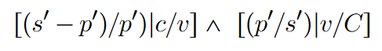
- The more the constant capital (c) increases, the more the difference between the total capital (C) and the variable capital (v) grows, and the smaller the proportion expressed by the rate of profit (p’=s/C) in comparison with the rate of surplus-value (s’=s/v), or the proportion yield as rate of profit from the rate of surplus-value (p’/s’) that is related to the excess of the rate of profit (s’-p’):
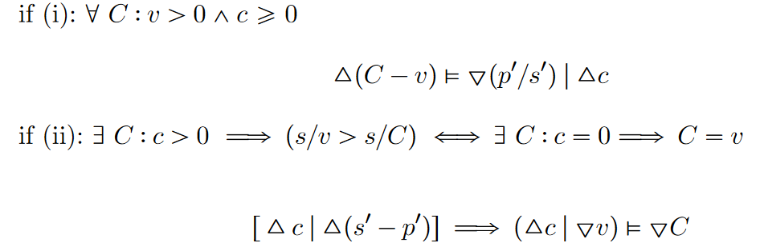
As a whole, the reproduction of finance capital (M-C-M’) implies the transformation of money-capital (M) into productive-capital (P), (M — C — M’) ——> (M — P — C — M’), for an expected higher rate of profit (p’) equal to the ratio between the surplus-value (s) already frozen in certain volume of commodity-capital (C) -a super-profit produced by the selected super-exploitation of higher productive unpaid concrete work-time-life due to the lower wages paid in comparison of the magnitude of variable capital (v) that would be invested in the national-economies” where the realization of the surplus-value (s) exploited is converted into augmented money (M’) as profit-, and the total capital advanced (C) (Marx, [30 April 1868]1988:21-24; Bukharin, [1915]1966:81-83).
The circuit of mining capital accumulation of the imperialist bourgeoisies cannot achieve the transformation of their finance capital into increased money-capital, as total profit, because of the operation of the following mechanisms over the dynamics of the metamorphosis process by which the surplus-value takes its profit form (see above):
1) delaying the circulation of the surplus-value transformation into total profit, and
2) disrupting the expected organic composition of finance capital advanced in the production of surplus-value, and in its posterior transformation into total profit; which
3) trigger the gold hoarding by imperialists bank state trusts, because gold-holdings are money-capital and commodity-capital at the same time, but in contrast with monetized-capital in form of paper ("monopoly") money -pure currency-, gold-money-capital can hold its surplus-value form of commodity-capital, in that manner delaying its transformation in profit when the rate of profit decreases;
4) as we just explained above, the increment of the constant capital magnitude decreases the rate of profit, as a reduced amount of surplus-value is transformed into total profit, as a result of the delay in the circulation of the finance capital due to the antisystemic obstruction of anti-mining struggles;
5) indeed, disrupting the rate of surplus value and rate of profit of the imperialists bourgeoisies in ongoing militarist expansion of their mining accumulation circuits by mean of imperialist wars or imperialists interventions oriented to establish its relations of production in the “national-economies" at which the mining precious “raw" materials are situated.
In this sense, the indigenous-cholo peasantry antimining struggles challenge the circulation of the finance capital of the imperialists mining bourgeoisies, obstructing the production and circulation of mining commodities. The circuit of mining capital accumulation obstruction reduce the amount of surplus-value able for its realization as profit, reached by the sell of the mineral raw materials shaped as a volume of commodity-capital. If the time of circulation and organic finance capital composition are disrupted, the expected rate of super-profit decreases, and the gold-money-commodity-capital appears as the preferred shape of capital to hold its surplus-value form, until the rate of super-profit increases enough to finish its circulation process as pure monetized total profit.
In this point a psychological, if not substantial argument can hold. The economic rationality as is contextual, expect an opportunity, a sign of fortune which enhance its virtue. The window of opportunity should have the size correspondent to the satisfaction of its ideological expectation about how much they (the top-layer capitalists syndicated in international bank state capitalists trusts holding the world-gold-capital) can increase its class-differentiation by the kind of opportunity for capital reproduction that can satisfy its will for power as the metamorphosis of becoming something differentiated, sublimated, alienated by the exploitation and domination of others as a mean and necessary-sufficient condition of their existence in the economic formation which they constitute as a top-world-imperialist-class integrated by the capitalists syndicated in international bank states capitalists trusts.
This means became differentiated, alienated, sublimated, obviously not (only) from its world antagonistic classes (as history don't repeats, its not a primitive accumulation process of world-scale dispossession). That was already granted at a world-scale, since the inter-“national" division of labor of the world-economy was completing or saturating its relations of production, while developed its concentration and centralization processes inter-“nationally". Of which are a part the horizontal decentralization of the Sino-American economic formations and their relations of production and circulation, under breaking conditions of shared imperialism. As well as the imperialists wars and military interventions by which the geopolitical and geoeconomic contention develops their competition. The class-differentiation process is an intended result of the economic and political war in which the top-layer members of the international bank capitalists states trusts contend.
The differentiation process is not driven by the production of surplus-value in the shape of commodity-capital, but by the circulation of overaccumulated world-capital funds as finance-money-capital into a reproduction process by a higher rate or profit. The resulted accumulation of augmented world-capital is expected to reach a quantitative critical point in which a qualitative change of world-scale effects is achieved in the concentration of capital process which implied the preparation of the most crude of the imperialists wars. As in that manner the advancement of competitive and old forces of production are destroyed, and the new relations of production can be implanted to organize a world-economy for the reproduction of the world-capital of this top-layer of capitalists syndicated in the international bank state capitalists trusts ruling the geopolitical and geoeconomical contention.
With not only consequences over the world-economy class structure and modes of production, but mainly over the natural, cultural, and historical conditions for our social reproduction. In their, atomized psychology the idea by which: a higher amount of capital advanced as finance capital into higher productive "national-economies" is expected to result in a higher rate of profit. Indeed, the hoarding of gold, operates as a reserve fund which expresses the contradiction between the accumulation of monetized-money-capital and gold-money-capital in the national reserves of U.S. and China, particularly. It appears as if U.S. bank capitalists state trust is being ready for the transformation of a certain volume of gold-money-capital in monetized-capital beared in an inverse proportion by China's bank capitalist state trust. And viceversa. Their will of sublimation, their will of power, drives its competitive voracity in a gold rush. Hoarded the fund of gold, they wait for an opportunity to finish its circulation as money-capital.
The reproduction of an immense volume of monetized-capital (accumulated in the shape of U.S. dollar hegemonic currency) under the existing conditions impossible to be productively invested in the reproduction of their capital. From which point, a portion of its total profit, correspondent to the enterprise profit will circulate as advanced (finance) capital in the next stage of mining production, another part will be paid as rent, another is accumulated by interest-profit. The part of enterprise-profit which is impossible to invest as advanced capital, is overaccumulated as a reserve fund of money-capital from which a minuscule portion can be expended by the top-layer capitalists bearing it.
Meanwhile, the historical conditions expressed in indigenous-cholo antimining struggles of Los Andes in direct contention to the most advanced economic formations of imperialism world-economy, also evidence an advanced development of the historical process of class struggle. The antimining struggles have effects on a world scale on the decrease in the rate of profit due to the obstruction of the time of circulation in the transformation of surplus-value into profit, in addition to disturbing the organic composition of the capital advanced by the mining circuit of reproduction, in the monetary hoarding of gold by the bank capitalists state trusts. They have an antisystemic effect on the circuit of extended capital accumulation of the imperialist bourgeoisies by blocking the expansion of their extractive mining frontier, and obstructing the production and trade of minerals in general, and gold in particular.

Antimining struggles blocking the expansion of the U.S. gold mining extractive frontier in Cajamarca
The expansion of the extractive frontier of Minera Yanacocha-Newmont in Cajamarca has been contested by an mining movement that employs what is called a unique front strategy. It has proven to be effective in creating sufficient people’s social power to confront imperialist mining. The harshness of the military’s repression against the popular and mainly peasant mining movement in Cajamarca revealed the cruelty of the imperialist domination in Peru, just after the democratic election of a president of nationalist and military background (Ollanta Humala). The mining struggles in Cajamarca taught us that peasant struggles can be interpreted and developed as anti-imperialist struggles, since they imply a class confrontation between two extremes of capitalist accumulation: the international mining bourgeoisie and the indigenous peasantry. The challenge that mining struggles represent for the central nucleus of imperialist domination in countries where mining constitutes the main enclave of capitalist accumulation, points to the strategic nature of the mining struggles. They are the spearhead for the development of an antisystemic movement, as well as critical for the geo-economics needs of the dynamics of capital accumulation during the current systemic crisis (Veltmeyer 2015:124; Wallerstein 2002:38).
The mining struggles for the defense of Quilish Mountain and the water sources of Cajamarca in 2004 had shown the effectiveness of the unique front strategy: they have joined the efforts of multiple organizations. These include: peasant nightwatch organizations (“rondas campesinas”), irrigation boards (“juntas de riego”), urban nightwatch organizations (“rondas urbanas”), the teachers union at the provincial and district level (SUTEP-Cajamarca), fractions of the PCP-PR of Cajamarca, and university students and environmental NGOs such as Ecovida and Grufides.
Since the beginning of the struggle against the Conga mining project of Minera Yanacocha-Newmont in November 2011, the environmental defense fronts confronted the government of the recently elected president Ollanta Humala who had promised to the peasants that Cajamarca’s lagoons would not be destroyed nor would mining be allowed without popular consent. In this context, the sustained mining campaign opposing Minera Yanacocha-Newmont's Conga project escalated, contesting not only to the U.S. gold mining company, but directly the administration and government of the former military captain and President Ollanta Humala.
The formation of the environmental defense fronts at the beginning of the first decade of the 2000s in Cajamarca was the result of a political coalition between the environmental NGOs –particularly Ecovida–, the teachers provincial union (SUTEP Cajamarca) and the peasant nightwatch organizations then controlled by the PCP-PR, as an effective strategy to unite the popular forces in defense of Cajamarca's water sources. However, after some time this coalition lost control of the popular mining movement. In this context, a new group of leaders, composed of radical professional politicians, garnered control of the movement, limiting the role of the PCP-PR and the environmental NGOs.
Thus, in September of 2010, Celendin's first declaration was made to create the Interprovincial Coordinator for the Defense of the Environment, which forged a new strong coalition for mining struggles including second-level organizations of five provinces located in the direct influence area of the Conga mining project (Interview LM2 03/06/2014). This coalition would allow coordination between the environmental NGOs, led by Marco Arana (GRUFIDES), and the radical fraction of the popular movement of Cajamarca led by Wilfredo Saavedra. As the latter was gaining strength among the peasant and urban bases of Cajamarca, bringing together fractions of the teacher’s union (SUTEP Cajamarca) and peasant and urban nightwatch organizations (“rondas campesinas y urbanas”) opposed to the control of the PCP-PR, the frictions between these sectors worsened.
With the formation of this new coalition, the sector of Wilfredo Saavedra would be in charge of learning and translating the environmental framework to a broader sector of the peasantry, university students and neighborhood organizations. This demonstrated the capacity of the radical sector leadership to further broaden the bases of the unique front against the expansion of the extractive frontier of Minera Yanacocha-Newmont. The radicalization of the struggle began on November 24, 2011, when the peasants of Bambamarca and Celendín took over the lagoons that the Conga Mining Project planned to destroy. This performance of struggle required an effective organizational structure that would allow the mobilization and rotation of 200 peasants every two days to prevent the machinery of Minera Yanacocha, the police and the military from entering the lagoons and taking control of water sources (Interview LM5 03/08/2014).
The magnitude of the repression carried out by the government of Ollanta Humala crudely demonstrates the operation of mining accumulation by repression against the peasantry of Cajamarca. The militarization of Cajamarca was order by decree RS 231-2012-DE, which imposed the state of emergency from May 29 to June 25, 2012 in the provinces of Cajamarca, Celendín and Hualgayoc. In this context, on July 3, 2012, during the 34th day of the regional strike (“paro regional indefinido”) in Cajamarca, the military forces killed four peasants in the town’s square of Celendín:
“Here, on July 3, it happened that the police and the military were down on the corner [..] when they started shooting at us, then the people who were here in the central square [of Celendín] began to run through different places […]; and the people […] took shelter here in the church of the Virgen del Carmen. And when the police and the military came […] wanting to break it down [the door] […]. The priests were inside […], the door of the church was open to shelter us because if it hadn't been open suddenly more of us would have been killed; but thank God the door was open, and we entered, more or less 200 people. We were sheltered inside from around 4[pm]in the afternoon until 8:30 at night, until the priest asked the Ombudsman of the Peruvian state to come and get us out: because we couldn't go out because the military and the police were full [at] [the courtyard of the church]. […] And then they thought that we had thrown stones at each other, we had killed each other with stones [referring to the fallacious and blatant lies of the then Minister of the Interior, who had “informed” that the [four] dead in Celendín were a result of stones thrown by the protesters themselves]. But it wasn't true because my son had the bullet that had entered his mouth. The first helicopter that came, then […] since he was filming the helicopter, like this [raises an arm and makes the gesture of holding a video camera or cell phone pointed at the sky] […] the bullet had entered through his mouth and had stayed […] in the brain. So that was what they had taken out [in the autopsy] because the little teeth here and the bones there [touches his mouth] had been found in his stomach” (SERVINDI 2014).
The mobilized groups in Celendín marched to the Municipality’s building to demand the town Mayor Mauro Silas to stay on the people’s side in their struggle to defend the lagoons. The shots made by the military from the balcony of the municipal building and from helicopters, exhibited the magnitude of the imperialist mining repression. The brutality of the military’s repression of the popular mining movement in Cajamarca revealed the imperialist nature of the domination exercised by the international mining bourgeoisie.

Obstructing China’s copper mining under imperialist U.S. domination in Apurímac
The cruelty of the imperialist repression against the mining workers during the 20th century reveals the magnitude of the repression of the mining struggle carried out by the peasantry today, after a century of political mining contention in Peru. The social formation that currently directly confronts extractive mining capital is the peasantry, not the mining proletariat. By claiming the defense of water, and and life against the extension of the extractive frontier, mining struggles show themselves to be absolutely antagonistic to the extractive capitalist accumulation process. That is, as a frontal struggle against the international mining bourgeoisie, and even beyond, the mining struggle confronts the capitalist system and the productive and commercial dynamics that sustain it on a global scale, blocking its reproduction. Faced with this problem, imperialist domination mobilized the armed military forces to enforce the interests of the mining bourgeoisie (Lust 2016:5).
On Friday, October 14, 2016, two hundred indigenous peasants from the communities of Choquecca, Quehuira, Allahua, Antuyo and Pumamarca, located in the province of Cotabambas (Apurímac), began a road blockade obstructing the trucks loaded with mineral ore through the mining road used by the Chinese capital company MMG Limited Las Bambas. The peasant communities demanded payment from the mining company for the use of a communal road within their territories, through which the mine site connects to the main mining road and the trucks loaded with mineral ore head to the port of Matarani in the region of Arequipa. The road blockade that started that morning was brutally cleared by the police, killing community member Quintino Cereceda Huiza with a bullet to the head and wounding twenty more peasants. A few days later, the Minister of the Interior (security) Carlos Basombrío, declared that the police forces were not authorized in any way to clear the road blockade that day (El Comercio 2016:8).
The communities of southern Cotabambas rebelled against the power of the Chinese mining company MMG Limited Las Bambas for 186 days until April 17, 2017, when the province of Cotabambas was assigned the state of emergency, authorizing military repression against community members. Although the mining struggle of the peasant communities of Cotabambas (Apurímac) against the Chinese mining company MMG Limited Las Bambas did not include expressly an "antimining" claim -as in Cajamarca and Cotopaxi- its direct target is the imperialist mining company, and indeed the magnitude of the repression executed to secure the interests of China’s mining bourgeoisie confirms the disposition of the armed forces to serve in shared imperialism conditions to guarantee the MMG mining operations by militarism.

Historical boundaries for imperialist mining militarism at the breakdown meantime of Sino-American shared imperialism: The antimining indigenous-cholo movement struggles against the Atico Canadian Mining in Cotopaxi, Ecuador
The constitution of the antimining national front of Ecuador (Frente Nacional Antiminero - FNA), evidences the outcome of the antimining contention scale shift process in its conjunction with the processes of polarization and identity formation. The level of coordination of the antimining struggles is higher and advanced than twenty years ago, the performances of struggles were emulated and adapted with success. Recently, only a few months ago during March, 2024, the Atico Canadian Mining attempted to pass an illegal socioenvironmental consultation as legitimate to claim the exploration of the La Plata project surrounding the indigenous-cholo communities of Las Pampas, Palo Quemado, Galápagos, La Florida in Sigchos, province of Cotopaxi. Peasant producers of the best \textit{panela} of the world and some of the better cattles of Ecuador opposed firmly to the militarized celebration of an ilegal and ilegitimate socio-environmetal consultation.
In a context in which the debate of the law instrument for the national regulation of the Consultation and Free, Prior and Informed Consent (FPIC) as an international instrument adopted by the Constitution of Ecuador of 2008, in complete correspondence with the recognition of the rights indigenous peoples and nationalities of the Ecuador, as an historical reform. The indigenous movement most important confederation of Ecuador, the CONAIE, as a member organization of the National Antimining Front of Ecuador (FNA), participated in the celebration of a permanent mobilization assembly of the FNA at the national scale, where the mining projects are located, in strategic solidarity with the antimining struggle campaign developing during those days in Sigchos, Cotopaxi, that left hundreds of peasants and activists injured, and Mesías Robayo Masapanta in coma after receiving a shot in the face.
The social formation which is developing with the constitution of the antimining political identity of the indigenous-cholo peasantry in historical resistance is a relational product of the political economy dynamics of imperialism and the perpetual militarism of its colonial policy over our territories. By which its antisystemic definition was historically, materially built, and correctly interpreted for their own interest as a world antagonist class challenging the top-layer economic formations of the world-economy of shared imperialism. Which we identify as inter-"national" bank state capitalist trusts in contention, with respective differentiated trajectories of concentration and centralization, most clearly emphasized at the present time in the Sino-American gradual rupture by horizontal decentralization, and its consequences over the decline of the rate of surplus-vale due to a relocation of an expected amount of variable capital to other "national-economies".
The use of shields to contest the bullets as an human act of life defense when unarmed masses of peasants, students, workers, are being shot by the army which is supposed to protect the life of the people but instead guarantee by militarism the reproduction of the finance capital beared by the top-layer of the international bank state capitalists. In which hands is accumulated the profit of mining capital production and circulation. The monopolist tendency and the fierce competition over the most important branch of industry in the world-economy of imperialism are the forces with which the process of horizontal capital decentralization of the Sino-American finance capital develops the new imperialist wars of re-partition to a higher point.
Under conditions of shared imperialism, the competition between China and U.S. inter-"national" bank state capitalists trusts are evidenced in the participation of transnational enterprises as Atico Canadian Mining, a result of vertical centralization by absorption of the canadian Toachi Mining Company, to attempt the exportation of gold and copper commodity-capital produced in Cotopaxi (Ecuador) to the Quigdao Port in China. The risk factors considered for March report of Atico Canadian Mining expressed: "[t]he Company is exposed to many risks in conducting its business, including but not limited to metal price risk as the Company derive its revenue from the sale of copper, gold, and silver; credit risk in the normal course of business; currency risk as the Company reports its financial statements in US dollars whereas the Company operates in jurisdictions that conducts its business in other currencies” (SGS Canada 2019).
Recognizing indeed, the profits are being severely affected by the currency depreciation of the U.S. dollar, as the mining commodity-capital will be in surplus-value form produced with advanced capital in the currency of U.S. dollar, as the operations are located in Ecuador. Furthermore, the credit risk augmented as the finance capital circulating in the operations of the Atico Canadian Mining in Ecuador should be beared by the China bank state capitalist trust for accumulation of their deficit in gold-money-capital compared to the U.S. total gold-capital reserves monetized expression in the hegemonic U.S. dollar currency (Figure 3).
Finally, but not last, the gold and copper price are gradually stopping to grow, due to the incremental tension between Beijing and Washington, due to the Palestine-Israel war, the gradual positioning of Russia over Ukraine, the U.K. drop in supporting military Israel genocide over Palestine civilian, the Iran effective military step-in the Palestine-Israel war, the increasing tension in Taiwan and the shameful electoral politics of the most advanced democracy of the world, support the concerns of Atico Canadian Mining. Its not an isolated sight or movement, is happening at the same time that the horizontal decentralization of the Sino-American finance capital is impacting the profit-seeking decisions of the layers of economic formations above as NVIDIA or Tesla.

Conclusions
The article shows that antimining struggles have an antisystemic effect on the mining circuit of extended capital accumulation, and effectively challenge imperialist domination in Peru. By blocking the expansion of mining’s territorial frontier and obstructing the production and circulation of mining commodities, mining struggles challenge the mining bourgeoisie and the circulation of its productive capital.
The development of the political identity which started to take form during the first years of the 2000s in the firsts antimining campaigns of struggle executed by the effective mobilization of the peasantry organizations in Cajamarca (Peru) under the strategy of the constitution of a unique front for the defense of the water and land against mining dispossession and destruction, by the diffusion of an environmental frame open to its appropriation by the indigenous-cholo peasantry organizations as Las Rondas Campesinas, socialist leaderships as the socialist vanguard which radicalized the antimining front during 2010 and 2012, left unions as the SUTEP, subnational parties and electoral politicians as the MAS of Cajamarca and the former subnational governor Gregorio Santos.
The effectiveness of obstructive mining performances in Peru was revealed at least since 2004, with the success of the mining protests against Minera Yanacocha-Newmont and the withdrawal of government authorization to explore the Quilish mountain in Cajamarca. The increasingly radical nature of the contentious performances by the peasants of Huambocancha Alta and Huambocancha Baja achieved an uninterrupted blockade of the access route to Minera Yanacocha-Newmont gold mine, and stalled the police forces sent to unblock it. Although it wasn’t the first time that highway was blocked during episodes of mining contention in Cajamarca, it is worth saying that such the blockade leads to the gradual stoppage of the mine’s gold mining activities, significantly affecting its production and profits (Mejía 2021:97).
Ross (2003:54, 62) points out that minerals are a type of natural resource whose transport is relatively easy to obstruct, which has implications for the duration and intensity of extractive conflicts. The blockade implied not only the impossibility of access and exit to the mine’s facilities, but also the expensive use of helicopters for the supply of fuel, equipment, labor and other supplies (Pérez Mundaca 2012:70-71). Thus, the obstructive performances blocking the Cajamarca-Bambamarca highway ended up drowning Minera Yanacocha-Newmont, proving to be an effective performance of struggle for almost the entire duration of the mining campaign for the defense of Quilish mountain (Mejía 2021:98-99).
Innovative obstructive performances shared in Apurímac and Cajamarca highlight how imperialist mining operates in Los Andes. The companies of the international mining bourgeoisies need to establish the flow of the extracted mineral either to a smelting plant -such as the Southern Peru Copper Corporation has in Moquegua-, or directly to the port of Matarani in Arequipa. As suggested by Ye et al. (2020:7), mining multinational corporations claim the monopolized control of the territory and its resources, but also of the entry and exit points from which mineral commodities are transported to a port for exportation, finally traded for export, where it completes its conversion into money-capital. In this sense, mining and mining struggles in Los Andes effectively block the expansion of the extractive mining frontier and obstruct the circuit of the imperialist bourgeoisies finance capital invested in mining. The indigenous peasantry is actually at the forefront of antisystemic movements challenging the reproduction of global capitalism to defend their water, their lands, and their “collective self” from imperialist mining.

The indigenous-cholo peasantry struggles against imperialist mining as an antisystemic movement
The antisystemic historical resistance in Los Andes is indigenous-cholo in its broad base, structurally placed in subordination by the negative dialectics of race, which created the international division of labor by the material expansion of the competitive semi-colonial policy for mining exploitation, trade, and hoarding of merchant capitals in its attempted transition toward the formation of the oligarchic banking bourgeoisies which held the modern world-system under four successive Western inner-transitions since the XVI century.
Antimining struggles in Los Andes antagonize these reproduction processes and mechanisms vital for the modern world-system, and the imperialist world-economy. If Andean mining struggles decreases the imperialist mining bourgeoisies' rate of profit, it's antisystemic effects should have differentiated consequences on the multilevel polity contention among the top-layer of the imperialist bourgeoisies ruling the U.S. and the top-layer of the imperialist bourgeoisie ruling China for the expansion of its circuit of capital accumulation. At the current breakdown of the modern world-system shared imperialism of Sino-American international bank state capitalists trusts, due to its capital horizontal centralization initiated during the '70s and held until the 2019, when began its horizontal decentralization. The horizontal decentralization process is expressed in the protectionist policies adopted by both imperialists bourgeoisies due to an increasing digression of their rate of profit (Figura 2 y Figura 3). During the breakdown of shared imperialism conditions, differentiated accumulation regimes ruling their capital concentration and centralization dynamics are sensible to the disruption of the circuit of capital reproduction in the strategic industries over which the higher rate of profit are made. Mining and particular, gold mining in Los Andes are core, strategic, metabolic, processes of capital production and circulation, Are structural processes of the world-economy of imperialism, the core of the circuit of the capital reproduction of the international bank state capitalists trusts, as are their finance capital and its imperialist bourgeoisies (including its domestic managers, the bureaucratic bourgeoisies) the ones operating the mines, and the militarism with which they realize its exploitation.
Indeed, the differentiated reproduction outcomes depend on the natural and cultural conditions, expressed in the organic composition of capital at each instance of the whole circuit of capital reproduction. The differentiation mechanism operating at the level of the rate of profit depends on the transformation of surplus-value into profit at a concrete time of circulation, and expected proportions of variable and constant capital consumption, given by the natural, cultural, and -as I argue here- by the historical conditions. Manifested in the Andean indigenous-cholo antimining struggles, as historical challengers formed with the constitution of the modern world-system and the foundational and metabolic --gold-mining--reproduction processes of the capitalist world-economy.
The antimining peasants’ struggles in Los Andes of South America effectively obstruct the conversion of the money invested as mining productive capital by different imperialist bourgeoisies in competition for the extension of its reproduction circuit scale. Employing its militarized policy over the territories cursed by the abundance of mineral commodities under different forms of militarism, as military and paramilitary interventions in Latin America, or as new imperialist wars as initially expressed in Ukraine and Palestine (or sooner Taiwan) ongoing multilevel polity conflicts.

The processes of production and circulation of mining imperialist productive capital had been challenged by proletarian mining workers' struggles in China at the coal and lead mines of Anyuan, Pinghsiang County (Kiangsi Province) and Shuikoushan, Changning (Hunan Province) between 1921 and 1927; as well as in Peru in episodes of mining contention identified as the massacres of Malpaso (1930), Toquepala (1966), and Cobriza (1971). Nevertheless, the cooperation between the peasants' movement and the proletarian mining workers in China developed in the Autumn Harvest Uprising of 1927. On Octorber of 1928, Mao Tse-Tung led this forces to the Chingkang Mountains, and the further armed struggle against Japanese and U.S. imperialism and shared imperialism (Mao, [1928]1967:63-69, 81-103).
In contrast, the extension of the peasants-workers revolutionary coalition is a matter of polemic between historians of the peasants' movement and mining worker's struggles in Peru. The development of the peasantry as a class for itself sparked at the final decades of the XX century, the indigenous uprising in Ecuador of 1990 and the Chiapas liberation by the EZLN in 1994, which preceded the resistance against the expansion of the mining extractive frontier accelerated since the first years of the XXI century.
Antimining struggles are historically rooted in the historical problem of land dispossession and indigenous socialism within the Andean peasantry. Economic claims are grounded in the survival of the quechua, kichwa, aymara, wankas, caranquis, cañaris, otavalos, pastos in the highlands, moches, valdivias, huancavilcas, afros in the coastal valleys, mapuches in the southern forests, and awajún, waoranis, cofanes, secoyas, shuaras, achuras, zaparas, among others in the Amazonian, the ankebain of Mamansoya (and the other inhabitants of other seven worlds connected with this (Ortiz Rescaniere, 1975)), survived to the colonization genocide of the original accumulation process in Los Andes. Culturally, materially, historically, the resistance of the "indigenous" peoples of Los Andes, reproduced and developed the intrinsic relation between the "indigenous" and the "land".

The dispossession and destruction of vital values for the social reproduction of the indigenous-cholo peasantry and the rural proletariat as the social formations entangled with the land and water, by the expansion of the mining extractive frontier is irreconcilable with the existence not only of the peasantry but for the reproduction of the proletariat surrounding the imperialist mining enclave. The territories cursed by the mining industry are object of total biodiversity extermination due to the destruction of the conditions for life in general, and not only the cultural or natural conditions for the reproduction of peasant economies.
Although past mining contention waves of antisystemic resistance occurred during transitional stages of the capitalist modern world-system development -i.e. as the mining proletariat struggles developed in Peru and Great Britain during the first quarter of the 1900s-, the current restructuring attempt of the modern capitalist world-economy not only depend on a completed transition in the afterward of U.S. hegemony breakdown. Since the liberalization of the gold price (Figure 1) in 1971, the extension of the mining extractive frontier particularly of gold production motivated by the demand of monetary gold holdings for national reserve’s banks, raised exponentially since 2001.
The tendency to accumulate monetary gold in national reserves that was strongly monopolistic under U.S. hegemony until the beginning of the new millennia, when it began to be followed not only by the European central banks of Germany, France and Italy, but also by Russia, India, Japon, and specifically China. The last mentioned bank state capitalist trust increased its acquisition of gold for its national reserves, as its superiority in monetary holdings compared to the U.S. (Figure 2) required a balance in proportion to its monetary-gold holdings (Figure 3) to overcome the U.S. dollar as hegemonic currency, and intensified its capital production by gold mining in national contexts under which the situation of Sino-American shared imperialism remains, as in Latin America.
The total reserves of China in 2021 (3,43 trillion US dollars) are 4.79 times the volume of total reserves of the U.S. for the same year (716,15 billion US dollars) (Fig.1). However, the U.S. total gold reserves for the same last year 2021 was of 475,95 billion, and China’s total gold reserves only ascend to 114,01 billion (0,114 trillion) (Figure 2). A long twentieth century of imperialism over gold mining countries holds a current U.S. high advantage in monetary gold holdings, which implies a non-actually completed transition to China as a new hegemonic state of global capitalism. mining and mining struggles against U.S. gold mining and China copper mining in Peru evidenced a complex dynamic of imperialist mining from which approaches of U.S. hegemonic crisis and the initiation of a fifth systemic cycle of accumulation with “Chinese characteristics” can be problematized beyond.
In the current critical juncture of capitalism's systemic chaos (Arrighi and Silver 1999), antimining struggles in Los Andes and Latin America take an anti-imperialistic and antisystemic role. To initiate a fifth systemic cycle of accumulation, the top-layer of capitalists syndicated in the international bank capitalist state trusts requires investing the enormous magnitude of money-capital already accumulated in the branches of industry where larger profits can be obtained. Until new industries or future technological innovations could offer higher super-profit, their productive capital will be allocated intensively in the branches of industry they already know can provide the highest rate of profit, as mining and gold mining in particular. A new material expansion phase is a necessary condition for another cycle of financial expansion (Arrighi, 1994), but at this time the extended accumulation circuit mechanism could be reaching its natural, cultural and historical limits. Not only climate change but also historical change constrains and obstructs capitalism reconstitution at the present.
Until the beginning of the Twenty First century, the rising tide of environmental struggles carried out by peasant mobilization against the imperialists mining bourgeoisies, takes particular relevance to the development of class struggle historical process, as the militarized dimension of capital accumulation is exhibited by the militarist policy executed against the indigenous-cholo antimining struggles in Los Andes. Antimining struggles require dedicated study and analysis of their effects on the political economy of imperialism, and as a priority field of contention for class struggle development in the Andean region considering the centrality of the mining circuit of capital reproduction during a period of shared imperialism breakout, ecological and productive systemic chaos. Indeed, antimining struggles develop as limits to capital accumulation and imperialist domination in Los Andes. As O'Connor (1984) tried to remind to other radical thinkers in the middle of the 80's, Marxist theorists “left few clues regarding possible 'external barriers' to capitalist accumulation in the form of either 'limits to growth' determined by the availability of natural resources or [...] limits to accumulation determined by cultural-ideological conditions of economic and social reproduction” (O´Connor 1984:6).
Antisystemic environmental socialist struggles, as he would also state, are a central field of contention "to combat the attempt by capital and the state to ideologically construct and politically use the current crisis to restructure economic, political, and social life with the sole purpose of renewed capitalist accumulation, including a new 'long wave' of ideological innovation” (O'Connor 1984:23). Nevertheless, the material challenge that environmental socialist struggles display over militarized accumulation, as in antimining struggles in Los Andes, is showing a much further development not only restricted to the ideological struggles mentioned by James O'Connor. But bravely contesting effectively in absolute asymmetry of arms, the most powerful economic formations of the world-economy of imperialism executing its militarism. And in that manner constituting the "collective self" identity of the indigenous-cholo historical antisystemic resistance, in absolute antagonism with the reproduction of the international bank capitalist state trusts as the bearers of the finance capital circulating in the production and circulation of mining-commodity-capital, and most precious gold-money-commodity-capital. The readers will judge if we contribute to answer to the question: How do the antimining struggles have antisystemic effects over the capital reproduction of imperialist bourgeoisies? Opening a multi-dimensional and multilevel polity scale approach to the study of the antisystemic effects executed by the indigenous-cholo antimining struggles in Los Andes, as antisystemic challenges of historical resistance.

Figuras
Figure 1. Gold price in U.S. current dollars and China current Yuan, 1960-2023
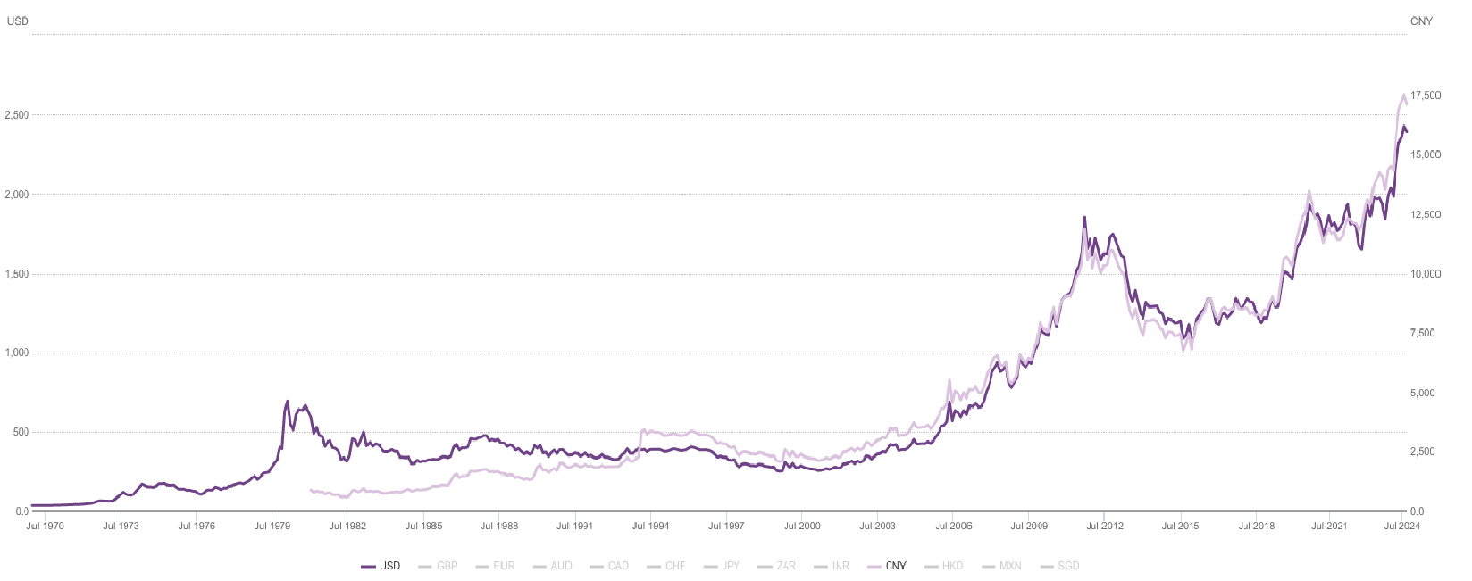
Source: World Gold Council Price Data.

Figure 2. Total capital reserve funds in monetized-capital (U.S. current dollars) of
the top-ten gold-bearers national-economies, 1960-2023
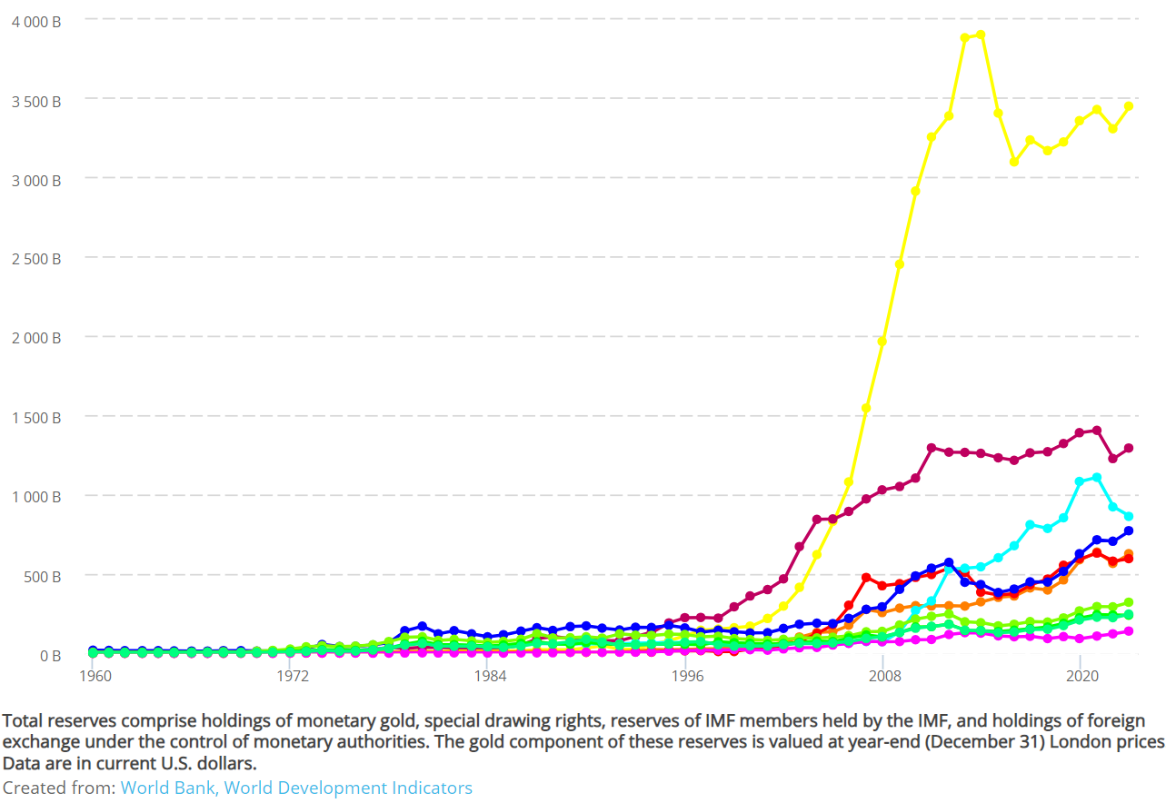
Figure 3. Total capital reserve funds in gold-money-capital (U.S. current dollars) of
the top-ten gold-bearers national-economies, 1960-2023
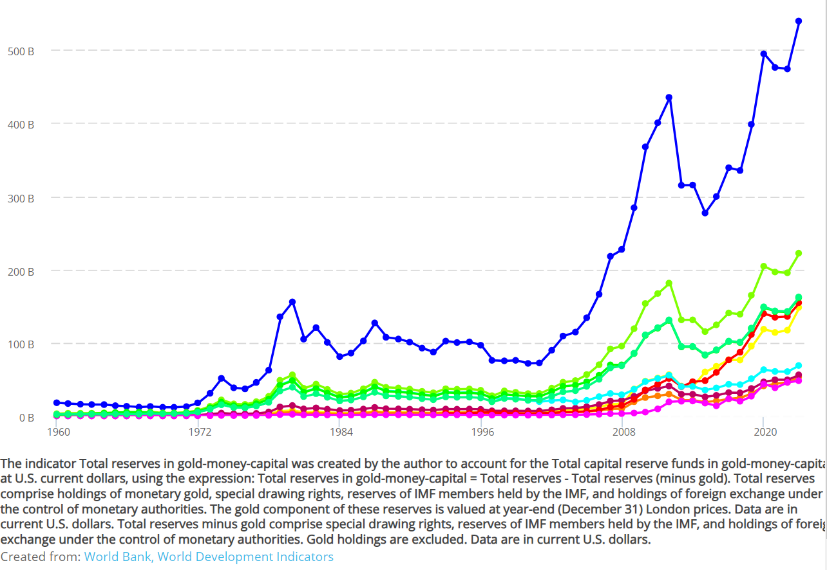
Figure 4. China and U.S. total capital reserve funds in gold-money-capital (U.S.
current dollars), 2000-2023
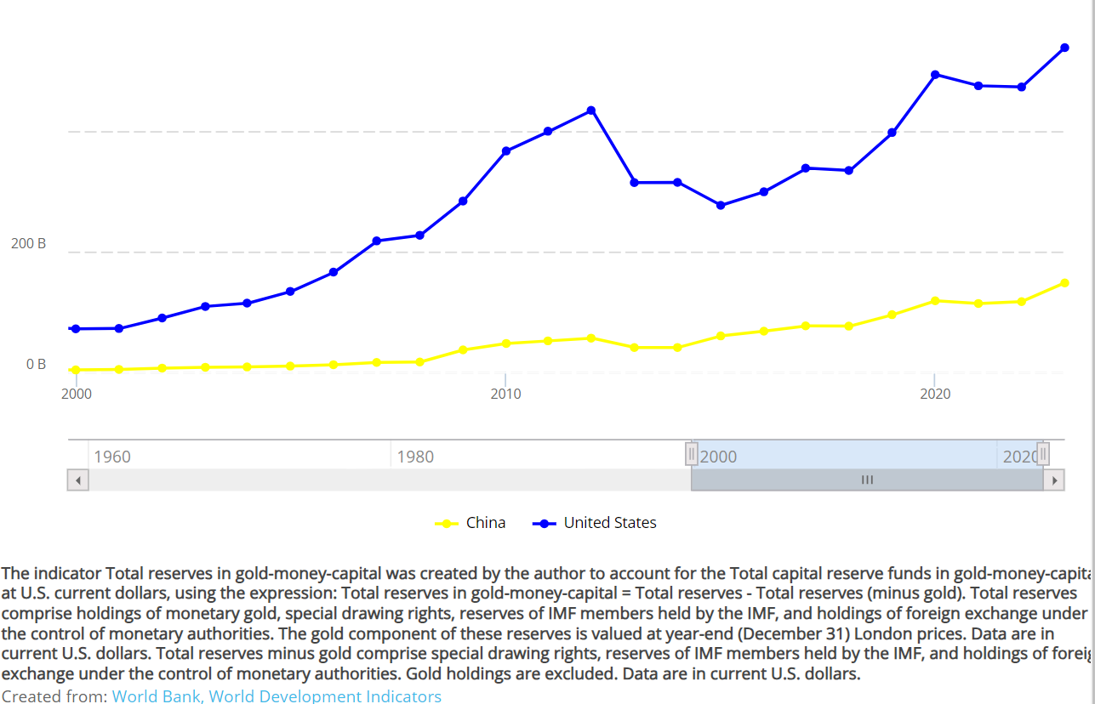

Referencias
Abu-Lughod, Janet L. 1991, Before European Hegemony: The World System A. D. 1250-1350, 1. publ., paperback., New York: Oxford Univ. Press.
Anderson, Kevin B. and Peter Hudis 2007, ‘Dialectic’, in The Blackwell Encyclopedia of Sociology, edited by George Ritzer, 1st ed., Wiley.
Arboleda, Martín 2020, Planetary Mine: Territories of Extraction under Late Capitalism, Brooklyn: Verso Books.
Arrighi, Giovanni 1994, The Long Twentieth Century: Money, Power, and the Origins of Our Times, London ; New York: Verso.
Arrighi, Giovanni, Terence K. Hopkins, and Immanuel Maurice Wallerstein 1989, Antisystemic Movements, London ; New York: Verso.
Arrighi, Giovanni, and Beverly J. Silver, eds. 1999, Chaos and Governance in the Modern World System, . Contradictions of modernity 10, Minneapolis: University of Minnesota Press.
Bukharin, Nikolai 1966, Imperialism and World Economy, 1st English ed., New York: Howard Fertig.
Bundschuh, Jochen, Marta I. Litter, Faruque Parvez, Gabriela Román-Ross, Hugo B. Nicolli, Jiin-Shuh Jean, Chen-Wuing Liu, Dina López, María A. Armienta, Luiz R.G. Guilherme, Alina Gomez Cuevas, Lorena Cornejo, Luis Cumbal, and Regla Toujaguez 2011, ‘One century of arsenic exposure in Latin America: A review of history and occurrence from 14 countries’, The Science of The Total Environment, 429, 2–35.
Cueva, Agustín 1999, El desarrollo del capitalismo en América Latina: ensayo de interpretación histórica, 17. ed. aum., . Historia, México, D.F: Siglo Veintiuno Ed.
De La Cadena, Marisol 2005, ‘The production of other knowledges and its tensions: From Andeanist Anthropology to Interculturalidad?’, Journal of the World Anthropology Network, (1), 13–33.
——— 2010, ‘Indigenous Cosmopolitics in the Andes: Conceptual Reflections beyond “Politics”’, Cultural Anthropology, 25(2), 334–70.
Flores Galindo, Alberto. 2010, In Search of an Inca : Identity and Utopia in the Andes, Ed. Carlos Aguirre, Charles F. Walker, and Willie. Hiatt, . New approaches to the Americas., New York: Cambridge University Press.
Iza, Leónidas, Andrés Tapia, and Andrés Madrid 2020, Estallido: La Rebelión de Octubre En Ecuador, 1. ed., Quito: Red Kapari.
Jiménez, Sol Pérez 2020, ‘Grupo México: Epítome de la deshumanización y la barbarie del extractivismo’, Ecología Política, (60), 24–32.
Lenin, V. I. 1914, ‘Conspectus of Hegel’s book The Science of Logic’, in V. I. Lenin Collected Works. Philosophical Notebooks, Moscow: Progress Publishers.
——— 1964, ‘Imperialism, the highest stage of capitalism. A popular outline’, in V. I. Lenin Collected Works. December 1915 - July 1916, Moscow: Progress Publishers.
Luxemburg, Rosa 2015, ‘The complete works of Rosa Luxemburg. Volume II, Economic Writings 2’, in The Accumulation of Capital: A Contribution to the Economic Theory of Imperialism, edited by Peter Hudis and Paul le Blanc, trans. Nicholas Gray and George Shriver, London: Verso.
Mao, Tse-Tung 1967, ‘The Struggle in the Chingkang Mountains’, in Selected works of Mao Tse-tung., Peking: Foreign Languages Press.
Mariátegui, José Carlos 1929, ‘The New Peru.’, Nation, 128(3315), 78–79.
——— 2011, ‘On the Character of Peruvian Society’, in Jos Carlos Maritegui: An Anthology, edited by Harry E Vanden and Marc Becker, New York: New York University Press.
Marx, Karl 1976, Capital. A Critique of Political Economy, Trans. Ben Fowkes, Vol. 1. 3 vols., New York: Penguin Books.
——— 1988, ‘12. Letter from Marx to Engels in Manchester. 30 April 1868’, in Karl Marx, Frederick Engels : Collected Works, by by Karl Marx and Friedrich Engels, New York: International Publishers.
——— 2016, Marx’s Economic Manuscript of 1864-1865, Ed. Fred Moseley. Trans. Ben Fowkes, . Historical Materialism 100, Leiden ; Boston: Brill.
Mejía, José Manuel 2021, ‘Cambio de escala en la contienda anti-minera peruana. Construcción de teoría a partir del conflicto por la exploración del cerro Quilish en Cajamarca’, Quito: Facultad Latinoamericana de Ciencias Sociales - Sede Ecuador.
Mejía Villena, José Manuel 2024, ‘Luchas campesinas contra la expansión de la frontera extractiva: minería imperialista y conflicto de clases en Cajamarca, Perú’, Quito: Universidad Andina Simón Bolívar, Sede Ecuador.
Melgar Bao, Ricardo 2020, ‘Izquierdas y cultura militante en el frente minero: Perú 1928-1930’, Avances del Cesor, 17(22), 127–48.
Merton, Robert K. 1948, ‘The Self-Fulfilling Prophecy’, The Antioch Review, 8(2), 193–210.
Montoya, Gustavo, and Homero Quiroz, eds. 2023, Estallido Popular. Protesta y Masacre En Perú, 2022-2023, Lima: Estallido Editorial & Editorial Horizonte.
O’Connor, James 1984, Accumulation Crisis, New York: B. Blackwell.
Ortiz Rescanière, Alejandro 1975, ‘El orden secoya o el árbol del universo’, Textual, (10), 50–60.
Pérez Mundaca, José 2012, Conflicto Minero En El Perú. Caso Yanacocha (Cambios y Permanencias), Cajamarca: Universidad Nacional de Cajamarca.
Quijano, Aníbal 1980, ‘Lo cholo y el conflicto cultural en el Perú’, in Dominación y cultura. Lo cholo y el conflicto cultural en el Perú, Lima: Mosca Azul Editores.
——— 1988, ‘Imperialismo, clases sociales y estado en el Perú: 1985-1930’, in Clases sociales y crisis política en América Latina: Seminario de Oaxaca, edited by Raúl Benítez Zenteno, Quinta., México, MX: Siglo Veintiuno.
——— 2007, ‘COLONIALITY AND MODERNITY/RATIONALITY’, Cultural studies (London, England), 21(2–3), 168–78.
——— 2024, Aníbal Quijano: Foundational Essays on the Coloniality of Power, Durham: Duke University Press.
Quijano, Aníbal and Immanuel Maurice Wallerstein 1992, ‘Americanity as a concept; or, The Americas in the modern world-system’, International Social Science Journal, XLIV(4), 549–57.
Ross, Michael L. 2003, ‘Oil, Drugs, and Diamonds: The Varying Roles of Natural Resources in Civil War’, The political economy of armed conflict: beyond greed and grievance, Ed. Karen Ballentine and Jake Sherman, 47–70.
SGS Canada 2019, ‘Amended and restated n° 43-101 preliminary economic assessment of the La Mina VMS project, Cotopaxi province, Ecuador’, SGS.
Tilly, Charles and Sidney Tarrow 2015, Contentious Politics, London: Paradigm Publishers.
Valcárcel, Luis Eduardo 1927, Tempestad En Los Andes, . Biblioteca ‘Amauta’, Lima: Editorial Minerva.
Veltmeyer, Henry 2015, ‘The New Geoeconomics of Capital in Latin America’, in Beyond Free Trade.
Wallerstein, Immanuel 2002, ‘New Revolts Against the System’, New Left Review, 18, 29–39.
Walsh, Catherine E., Walter D. Mignolo, and Rita Segato 2024, ‘Introduction’, in Aníbal Quijano: Foundational Essays on the Coloniality of Power, edited by Walter D. Mignolo, Rita Segato, and Catherine E. Walsh, Durham: Duke University Press.

See Lenin 1914, and Anderson and Hudis 2007.
“La economía mundo incluye todos estos fenómenos económicos que, en definitiva, se basan en las relaciones entre seres humanos envueltas en el proceso de producción. En general, todo el proceso de la vida económica mundial en los tiempos modernos se reduce a la producción de plusvalor y a su distribución entre los diversos grupos y subgrupos de la burguesía sobre la base de una reproducción cada vez más amplia de las relaciones entre dos clases: la clase del proletariado mundial, por una parte, y la burguesía mundial, por otra” (Bukharin [1929]1966:26–27).
“Social sites consists of loci in which organized human action occurs; they include individuals, aspects of individuals, organizations, networks, and places” (Tilly 2002:xi). Arrighi et al. (1989) used the category locales or social locales in the same direction as the category social sites defined by Tilly. We are considering the definition of social sites as a plausible translation of the category social locales from the world-system analysis to which we believe is congruent.
“The development of joint stock companies, which made it possible to use the capital of a considerable number of individual entrepreneurs, and which radically undermined the principle of individual ownership of enterprises, created the prerequisites for large monopolistic associations of entrepreneurs. Concentration of capital assumed a new form here, namely, the form of concentration in trusts. Capital accumulation no more increased the capital of individual producers; it turned into a means of increasing the capital of entrepreneurs’ organizations. […] The individual production branches are in various ways knit together into one collective body, organized on a large scale. Finance capital seizes the entire country in an iron grip. “National economy” turns into one gigantic combined trust whose partners are the financial groups [banks] and the state. Such formations we call state capitalist trusts" (Bukharin [1915]1988:117-118).
Martín Arboleda stated: ““Already in the 1990s, before socalled “identity politics” gained prominence in international academic circles, Ecuadorian philosopher Bolívar Echeverría —a renowned theoretician of cultural syncretism and capitalist modernity in Latin America— was already puzzled by the self-defeating cultural essentialisms of emerging variants of Latin American indigenous politics. Pre-Hispanic cultures in the Americas, he argued, were undergirded by profoundly relational cosmologies and hence were unable to perceive the “Other” as independent alterity. The otherness they perceived in the Spanish colonizers was for them a mere variant of the sameness of their own collective self. The European mindset, on the other hand, always construed the cultural other in terms of radical alterity, as absolute negation of their own identity” (Arboleda 2020:210).
The “cholo group" is a social stratum which formation arises from the mass of the servile or semi-servile indigenous peasantry, differentiated by the incorporation of elements of Western-Creole culture. However, at the same time, they sustain, preserve, and recognize their difference and their origins in the indigenous culture and in the social structure of the indigenous peasantry, as the social formation from which we depart (Quijano 1980:63-65).
This concept is widely explained in the next section.
The Southern Peru Copper Corporation (SPC) was founded in 1952 by the American Mining and Smelting Company (ASARCO), which at the first decade of the 1900s operated the mining reproduction circuit of the finance capital bearers, as the Phelps Dodge Overseas Capital Company, the Cerro de Pasco Corporation (CPC), and the Newmont Mining Company, which concentrated already by 1901 20 percent of copper melting and 15 percent of copper refinement at a world¬scale (Pérez-Jiménez, 2020:25). Evidencing the continuum of exclusive monopolistic operation of the U.S. imperialist bourgeoisies centralized formations in Peru during the complete twentieth century.
“A certain quantity of metal that is insignificant in comparison with production as a whole is acknowledged as the pivot of the system. Hence, on top of the terrifying illustration of this ‘pivotal character’, the beautiful theoretical dualism. As long as it examines capital in its professional capacity, enlightened economics looks down on gold and silver with the utmost disdain, as being the most indifferent and useless form of capital. As soon as it deals with banking, however, this aspect of things is turned on its head, and it becomes capital par excellence, for whose preservation every other form of capital and labor have to be sacrificed. But in what way are gold and silver distinguished from other forms of wealth? Not by magnitude of value, for this is determined by the quantity of labor materialized in them. But rather as autonomous incarnations and expressions of the social character of wealth. The social existence that it has appears as something beyond, as a thing, object or commodity outside and alongside the real elements of social wealth. Credit, being a social form of wealth, displaces money and usurps its position. It is confidence in the social character of production that makes the money form of products appear as something merely evanescent and ideal, as a mere notion. But as soon as credit is shaken, and this is a necessary phase in the cycle of modern industry, all real wealth is supposed to be actually transformed into money, into gold and silver, a crazy demand, but one that necessarily grows out of the system itself. And the gold and silver that is supposed to satisfy these immense claims amounts in all to a few millions in the vaults of the bank. A drain of bullion, therefore, shows most strikingly by its effects that production is not really subjected to social control, as a social process, and that the social form of wealth exists alongside wealth itself as a thing. The bourgeois system does have this in common with earlier systems in so far as these are based on commodity trade and private exchange. But it is only with this system that the most striking and grotesque form of this absurd contradiction and paradox arises, because (1) in this system production for direct use-value, for the producer’s own use, is most completely abolished, so that wealth exists only as a social process expressed in the intertwinement of production and circulation; and (2) with the development of the credit system, the bourgeois system constantly strives to abolish this metallic barrier, which is both a material and an imaginary barrier to wealth and its movement, while time and time again hitting its head against it" (Marx, [1984-1865]2017:671-672).
“The function of the reserve fund, the bullion reserve of the Bank, a function that is not the sole determinant of its formation, since the fund can grow simply through the fact that external and internal trade is paralyzed, is threefold: (i) it is a reserve fund for international payments, in fact a reserve fund of world money; (ii) it is a reserve fund for domestic coin circulation, which expands and contracts; and (iii) (and this is connected with the banking function and has nothing to do with the function of money simply as money) it is a reserve fund for the payment of deposits and the convertibility of notes" (Marx [1864-1865]2017:667).
The concept of performances is defined as the relatively familiar and to some extent standardized and historically learned forms (e.g., the strike) that a category of political actors (e.g., mining workers) learns to demand the vindication of collective demands, in the face of a certain contender (e.g., private and state-owned mining companies) (Tilly and Tarrow 2015:14).
““The land,” Valcárcel writes in his study of the economic life of Tawantinsuyu, in native tradition, is the common mother: not only food but man himself comes from her womb. Land provides all wealth. The cult of the Mama Pacha, Mother Earth, is on par with the worship of the sun, and such as the sun does not belong to anyone in particular, neither does the planet. Agrarianism was born from the twin concepts of aboriginal ideology of communal ownership of land and the universal religion of the sun" (Mariátegui, 1928[2011]:72-73). In this manner the spontaneous and the free association of indigenous communities was possible to conceal with the existence of a ruling state class (Inkas) because of the different meaning that collective work have for the indigenous communities as something which is not sufferable, inclusive nowadays the community work in indigenous communities is more a collective dance with the soil than a mechanic activity for exhaustion and extraction, and its full of meaning and rituals. The indigenous communism is alive in the spirit of its sons and grandsons, detached from land by the violence of original accumulation and its sequels well known in Los Andes as massacres. The demonstration of the survival of indigenous socialism is not only in the “vestiges” left by the survival of indigenous communities, but also in the different types of chholo indigenous peasantry communities which appears in the development of the semi-feudal condition and capitalist expansion as a whole process: “Therefore, in indigenous villages where families are grouped and bonds of heritage and communal work have been extinguished, strong and tenacious habits of cooperation and solidarity that are the empirical expression of a communist spirit still exist. The community draws on this spirit. It is their body. When expropriation and redivision seem about to liquidate the community, Indigenous socialism always finds a way to reject, resist, or evade it.” (Mariátegui, 1928[2011]:98). Mariátegui's approach to the indigenous problem as the land problem, is oriented not only to challenge the oligarchy of landowners with military coalitions in control of land in Los Andes; but also, to target the bureaucratic bourgeoisie, and in that manner attacks the political structure of imperialism.
The size and quality of the mines opened in Los Andes located in volcanic geological formation are abundant in copper and gold, mainly, and the perforations required for the exploitation of the minerals evidence the liberation of arsenic into the underground water sources, permeating the soil as the main epidemiological structural threat of contamination with extremely compared magnitudes in Latin America (Bundschuh et al., 2011).

